Visualization Project

# The Topic

Analysis of the effect of weather (temperature and humidity) on RADAR range position error calculated for aircraft surveillance.

Goal is to determine if changes in temperature, humidity and air pressure significantly affect the nominal RADAR range error used by Air Traffic Control in Australia.

# The Background

What are the data components to visualize exactly?

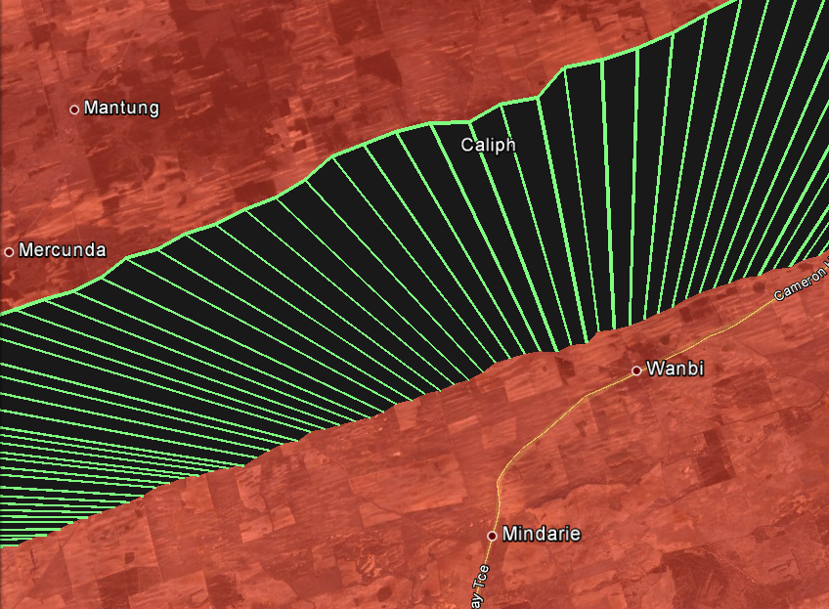

Radar measurements of aircraft at shown times

(Seconds past UTC)

85851.73

85855.71

85847.76

85839.81

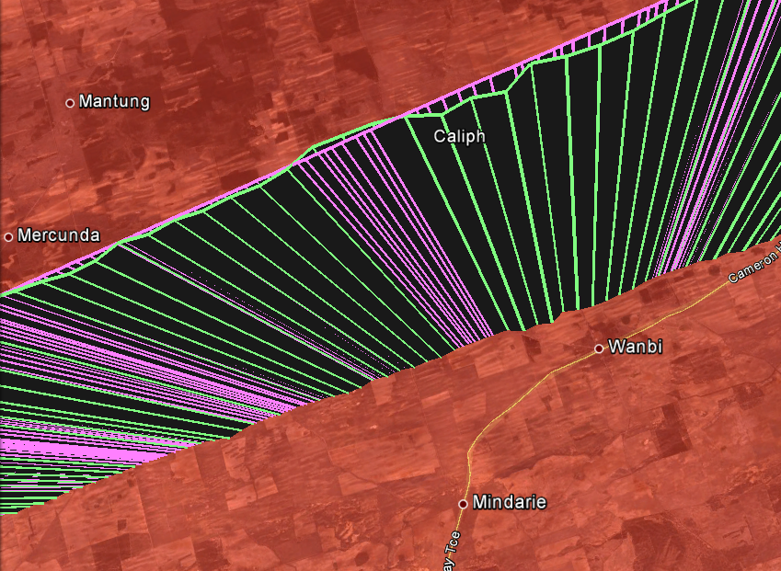

85851.73

85855.71

**1. Radar measurements (Green) on aircraft MODE S transponder at times shown with time (Seconds past UTC) for reference**

**Track reports are approximately every 4 seconds due to mechanical rotation of antenna of approx. 15 RPM**

**2. ADS-B reports (Pink) of same aircraft during same time period. These non-solicited reports are broadcast at shorter intervals (approximately every second) than Radar can acquire.**

**These positional reports originate from an onboard GPS unit and are also typically more accurate**

**3. Example of Radar Error. Where positions of both sources do not agree at same time, there is an error. This deviation is a typical example of Radar error1, and increases at further distances from the Radar**

**4. Aircraft altitude**

**This is reported separately and any error is not dependent upon Radar, and so is not considered here.**

**Radar only measures slant range to Radar, and relative bearing from it**

Figure Google Earth KML track illustration showing Radar Errors (differences in ADS-B and Radar positions)

1 ADS-B errors can be detected and discarded, so it is a Radar error.

This Radar error is measured in average metres of increase per NM, called Range Error Gain. So after 1 NM it is 1 unit of error , 2 NM it is 2 units, 3 NM it is 3, etc

Due to Radio Frequency signals travelling through a non-vacuum medium, the speed will slow depending on the medium density. Radar ranges are calculated here by time-of-flight between Radar and transponder signals from the aircraft. This time difference is converted to distance using a constant speed of light value (approximately half that of classical speed of light in a vacuum).

This speed value used, c, is constant and based on an average atmospheric density, which is in reality quite variable especially at lower elevation detection angles, where the atmosphere is denser and the signal travels quite a distance through it (up to. 256 Nautical Miles (NM), or approx. 475 kilometres). Aircraft are to be separated laterally by at least 5NM at 40,000ft or 3NM at lower altitudes.

Does the variability in atmospheric environment vary this averaged value c enough to significantly effect the Radar error ?

* For example, a variation of 10% could produce an error which impinges on the minimum separation.
* This is the issue to analyse and visualise. Further background data is included in the Appendix, which not strictly necessary to read, but may clarify some details.

Note that the error is most significant

* + - Where aircraft are furthest from the Radar, as the signal has to propagate the furthest, and induce the largest error.
    - Where aircraft are at a low elevation to the Radar, as the atmosphere is denser and the temperature and humidity profile is consistent over that range

Also of interest for this problem are

* + - Comparison at different geographic latitudes (subtropical vs temperate)
    - When there is an increase in air traffic (require minimal surveillance error)
    - When there are extreme or varied atmospheric conditions (summer vs winter, wet season vs rainy season, night vs day)

Interestingly the last two points are coincident. That is, the two busiest times for air travelling public for Australia is during Easter (entering Winter) and Christmas (Summer)

# The Data

As described in the Appendix, the comparison of Radar and ADS-B goes through several model translations, as Radar coordinates are in relative Range and Bearing and ADS-B is in latitude and longitude. The Appendix has more details on the derivation, here the details of the calculated components, and required criteria they must meet to be considered in the data set.

|  |  |  |  |
| --- | --- | --- | --- |
| RangeGain | This is the average increasing positional error that increases by this amount (in metres) every Nautical Mile of range | This is the prime error measurement for Radar inaccuracies. |  |
| Elevation | This is the vertical angle of the horizonal and the aircraft to the Radar | Require elevation to be 10 degrees or less, for error to be noticeable. |  |
| Overall Range | This is maximum range less minimum range of each track to the Radar | Require Track to have covered at least 200NM for a varied data set |  |
| Entries | The number of track reports detected in this analysis. | Require at least 100 entries for a decent population sample | Typically this is around 500 to 1500 reports.. |
| Temperature | This is the BOM temperature (units Celsius) | Compare Range Gain at extreme values to site average | Bureau of Meteorology |
| Mean Sea Level (MSL) Pressure | This is the Air Pressure at Sea Level (units hPa) | Compare Range Gain at extreme values to site average | Bureau of Meteorology |
| Relative Humidity | Percentage of moisture in the air | Compare Range Gain at extreme values to site average | Bureau of Meteorology |

# The Sites

The two Enroute Radars at Cairns (Hahn Tableland) and Melbourne (Mount Macedon) we selected as have

* + - Large physical separation in latitude for differing weather conditions
    - Both have large number of daily flights in detection range

BOM stores last 14 months of data, which I retrieved in March 2022 for the locations:

* + - Melbourne Airport
      * <http://www.bom.gov.au/climate/dwo/IDCJDW3049.latest.shtml>
    - Cairns Airport
      * <http://www.bom.gov.au/climate/dwo/IDCJDW4024.latest.shtml>

These data files are also located in my git repository <https://github.com/yetanotherpassword/cosc3000>

# The Big Picture

If we plot the individually calculated Range Error Gain of each criteria compliant track, against every day over one year, and colour code each against the 3 environmental metrics (Temperature, Humidity and Atmospheric Pressure) we would see for Cairns :

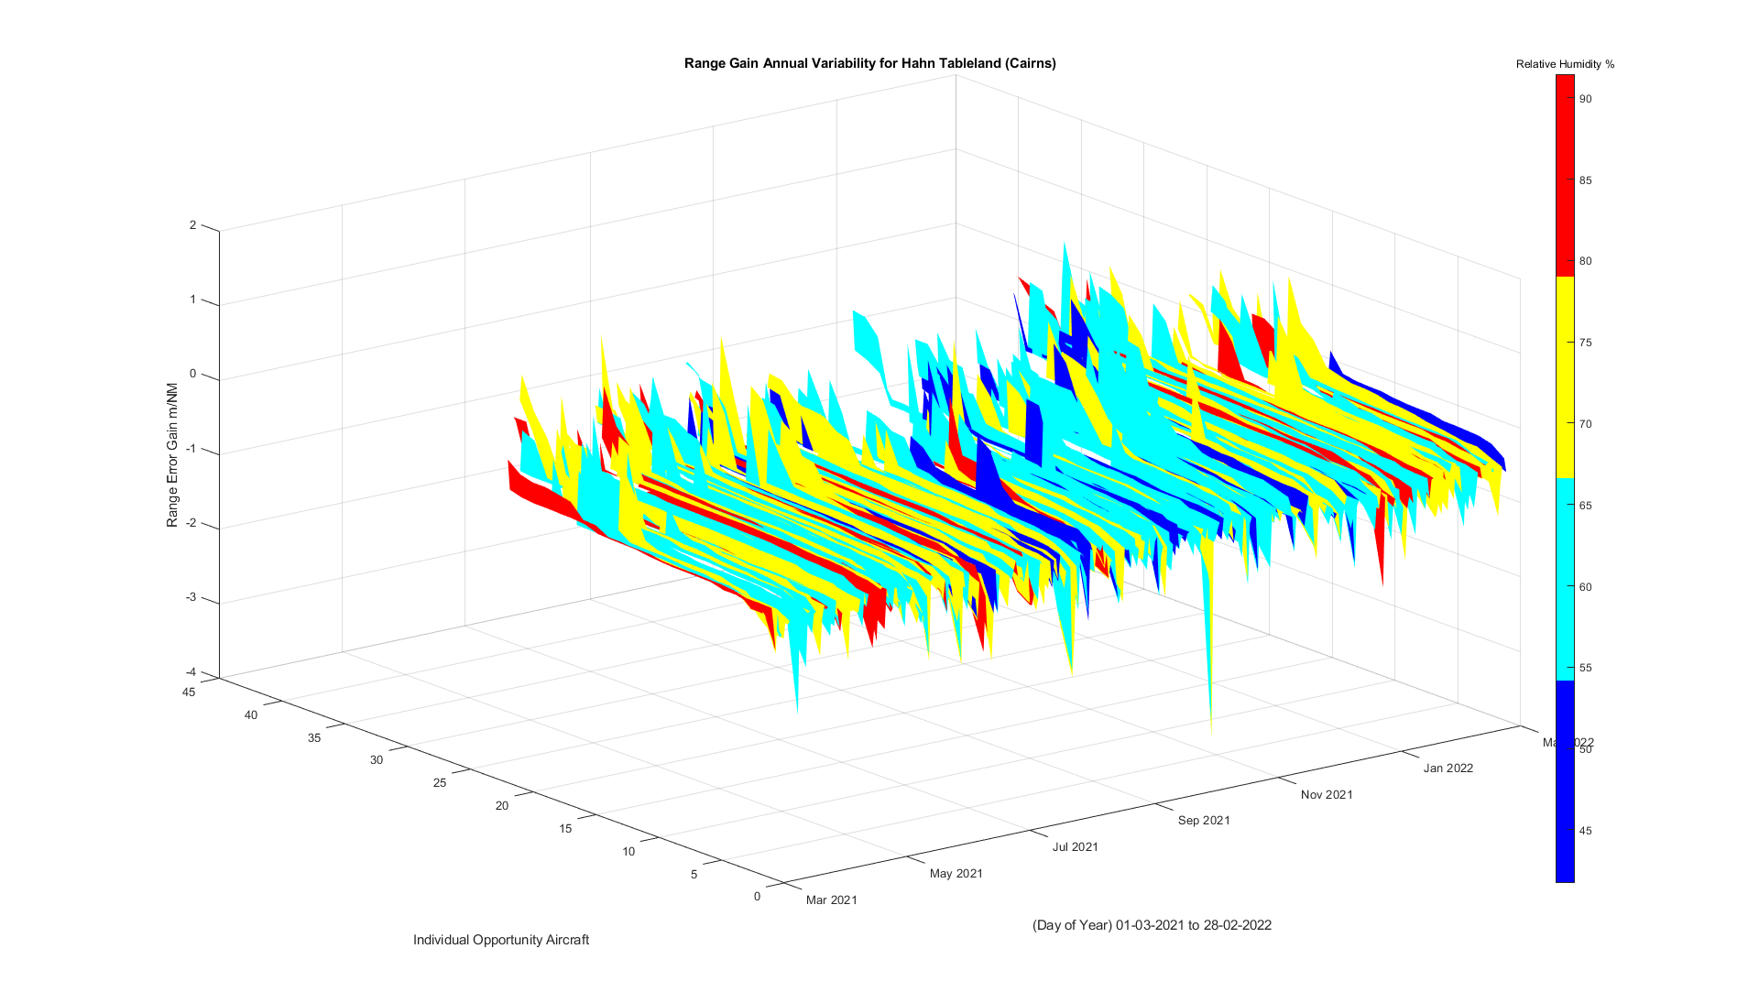

Figure Range Gain Distribution over 12 months colour coded to Relative Humidity for Cairns

For each of the 3 environmental metrics, they are colour coded into 4 equal portions over the total minimum and maximum values in the given data set. This is done to visualise easier the extreme and mid-range values.

These graphs are also available as PDF animations in Appendix A, in order to provide multiple viewing angles.

Also for each day the tracks are sorted in ascending order of its individual range gain calculation. This is done in order to better see the features, as their order does not matter. So there is no meaning in the ascension of the Range Error Gain across the number of tracks.

From these 3 graphs there is no obvious trend. That is, all peaks troughs and valleys appear to cut across all colours of each atmospheric metric.

It is important to only look for correlation with the height (ie Z axis) with colour first. There is not much extra knowledge in colour against the X or Y axis, i.e. summer is hot and winter is cold, or there are less flights when there is a low pressure system (e.g. cyclone)

Yearly Min Temp was -0.100000 C on 09/07/2021

Yearly Max Temp was 9.700000 C on 22/07/2021

Daily 9am Min Temp was 3.200000 C on 09/07/2021 (with RelH 89.000000 %)

Daily 9am Max Temp was 29.800000 C on 01/01/2022 (with RelH 27.000000 %)

Daily 9am Min RelH was 27.000000 % on 01/01/2022 (with Temp 29.800000 C)

Daily 9am Max RelH was 98.000000 % on 26/11/2021 (with Temp 13.900000 C)

Daily 3pm Min Temp was 6.500000 C on 20/09/2021 (with RelH 83.000000 %)

Daily 3pm Max Temp was 36.900000 C on 31/12/2021 (with RelH 15.000000 %)

Daily 3pm Min RelH was 15.000000 % on 31/12/2021 (with Temp 29.000000 C)

Daily 3pm Max RelH was 94.000000 % on 08/03/2021 (with Temp 16.200000 C)

Largest Range Error Gain was 2.969141 m/NM on 14/04/2021 by 0x7C6D80 for Mt Macedon (Melbourne)

Smallest Range Error Gain was -3.185763 m/NM on 12/03/2021 by 0x7C5DC1 for Mt Macedon (Melbourne)

Yearly Min Temp was 12.900000 C on 21/06/2021

Yearly Max Temp was 23.600000 C on 08/07/2021

Daily 9am Min Temp was 19.100000 C on 20/06/2021 (with RelH 59.000000 %)

Daily 9am Max Temp was 33.100000 C on 05/01/2022 (with RelH 49.000000 %)

Daily 9am Min RelH was 32.000000 % on 22/09/2021 (with Temp 23.900000 C)

Daily 9am Max RelH was 98.000000 % on 19/04/2021 (with Temp 23.700000 C)

Daily 3pm Min Temp was 21.300000 C on 09/08/2021 (with RelH 91.000000 %)

Daily 3pm Max Temp was 37.000000 C on 26/02/2022 (with RelH 33.000000 %)

Daily 3pm Min RelH was 21.000000 % on 16/10/2021 (with Temp 28.400000 C)

Daily 3pm Max RelH was 96.000000 % on 20/04/2021 (with Temp 24.100000 C)

Largest Range Error Gain was 1.684685 m/NM on 21/03/2021 by 0x7C6B0B for Hahn Tableland (Cairns)

Smallest Range Error Gain was -3.378708 m/NM on 05/10/2021 by 0x7C7A3F for Hahn Tableland (Cairns)

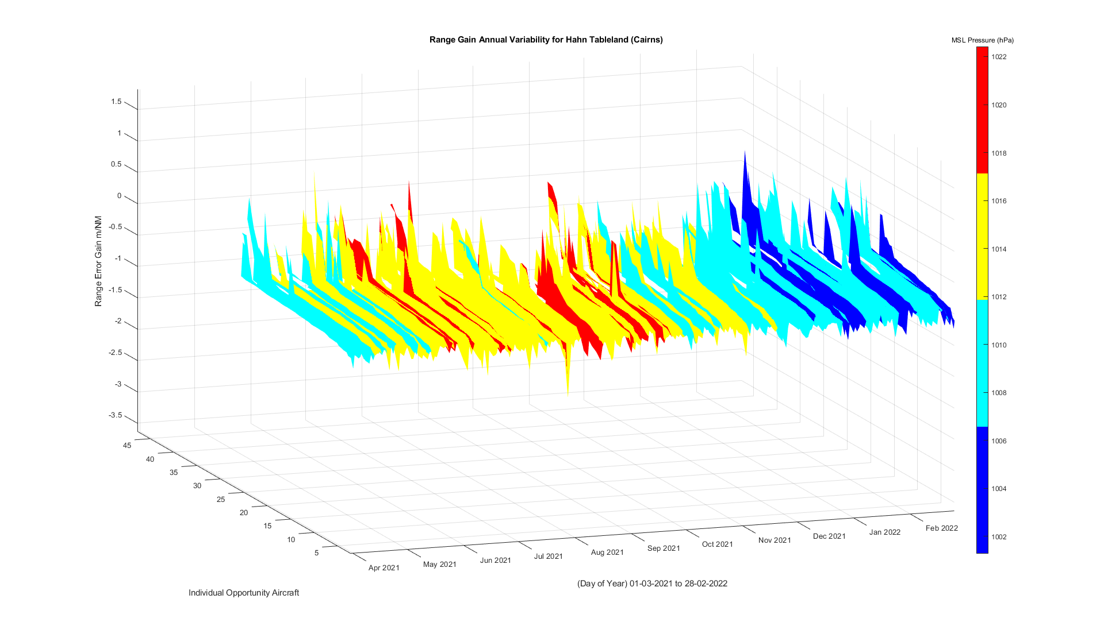

Figure Range Gain Distribution over 12 months colour coded to MSL Pressure for Cairns

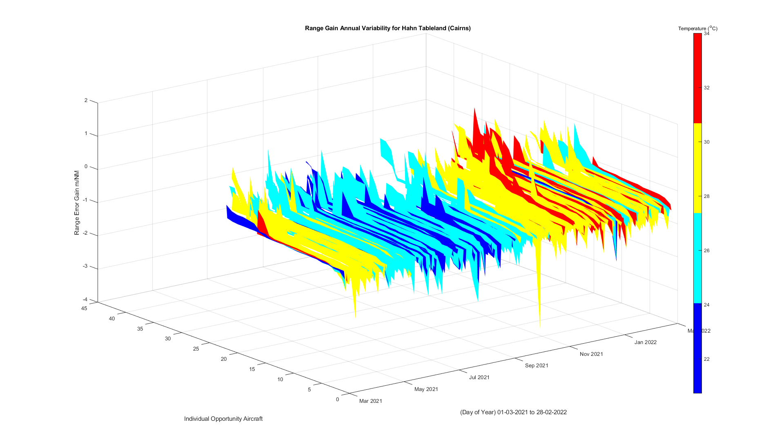

Figure Range Gain Distribution over 12 months colour coded to Temperature for Cairns

## 

Figure Range Gain Distribution over 12 months colour coded to Relative Humidity for Melbourne

## 

Figure Figure Gain Distribution over 12 months colour coded to Atmospheric Pressure for Melbourne

## The Selection Criteria

Below is an example of one track flown, showing the calculated error (our ‘signal’) in the selected elevation and time periods

Obviously, there is a lot of noise in the ‘signal’, not just from atmospheric activity but many other factors, such as antenna orientation, electrical noise in transmitted and received local environments, multipath reflections from other aircraft or geography, RF interference from ground based transmitters that may be in the line of sight, and so on.

If we perform a linear regression to a second order polynomial, as we know RF signal strength obeys the inverse squared decay rule, with respect to distance, we can find a curve of best fit.

If we extrapolate this to the maximum and minimum ranges we then have as shown below

This is one aircraft, we can perform the same for the remaining xxx on this day that meet this criteria and

## The Method

First the average Radar error is determined

# Appendix – References

Indra En Route Radar (Manufacture Specification)

<https://www.indracompany.com/sites/default/files/indra-monopulse_secondary_surveillance_mode_s_radar.pdf>

Resolution : 14.5 metres (1/128 NM)

Max Range : 256 NM

Max Altitude : 66,000 ft

## Nomenclature

Aircraft use several different identifications in flight, such as

* + - **Mode S Address** – this is a 6 digit Hexademical code, this is hard wired to the airframe and unique for every aircraft
    - **Mode A Address** – this is a 4 digit octal code, used by the older transponders, still valid, but can change during flight, and not necessarily unique (some codes are shared codes, used by multiple aircraft simultaneously – hard to programmatically separate reports)
    - **Callsign** – This is a 8 alphanumeric code, usually designated for the route it is flying – but not always – typically changes between flights.
    - **Registration** – This is more used in general aviation for Tail Identification on ground, it is used for logistics, regulation and business activities. Not usually used in flight operations.

# Appendix – Air Traffic Surveillance Primer

For Enroute Aircraft, aircraft surveillance is typically from two sources :

* Automatic Dependent Surveillance – Broadcast (or ADS-B) where the aircraft transmits (or ‘squits’) its GPS position and Identification (among other optional data) as digital packets (56 and 112 bits) on 1090 Mhz. This is a more modern form of surveillance and being digital in format, any errors or corrupt packets can be easily identified and discarded. Hence this method is not dependent upon the transport medium for direct positional measurements.
* Mode S Radar – This is a selective mode of interrogating aircraft, and minimises cross talk and garbling issues with the older Mode A Radar. The aircraft slant range is calculated by measuring the time delay of that aircraft’s transponder to reply to an interrogation. This time delay is converted to distance by an average speed of light measurement (C/2) through a model of the atmosphere. This estimate So there is a physical relationship between the atmosphere and the measurement of position. This means there is a relationship between the characteristics of the atmosphere and the error of position calculated by the Radar.
  + - Note another form of surveillance, Primary Radar, for non-compliant aircraft that have no transponder, or ADS-B system, is only used around landing and departure at airports. As such the range will be very close, so this error will be negligible.

Therefore by comparing Radar measurements against the ADS-B reports, the difference, or assumed error can be calculated

## Appendix – Range Range Error Calculation

# 

# 

# 

# 

# 

# Radar Calibration Process

When Radars are commissioned for use, a range of tests are performed to ensure accuracy. One test is flight trials where a specially equipped aircraft is chartered to fly orbits and overhead passes of the Radar to verify alignment. This is quite expensive to do and is not done again unless the Radar is taken out of service.

A similar ongoing alignment verification activity can be performed during normal operations. That is the comparison of aircraft’s Mode S Radar and ADS-B Reports. This is performed daily on all Radars country wide, and for this project I am utilising the last 12 months of this data.

Here we treat ADS-B data as truth data and compare to the Radar reported position, from which the Radar error is calculated. This process is detailed in the Appendix

These aircraft tracks will not, or very unlikely to fly the optimal path for the commissioning tests, which is a specific geometry around the Radar. So while not optimal for error measurements, it is still valid measuring especially for obtaining long term trends, and for statistical comparison, such as here.

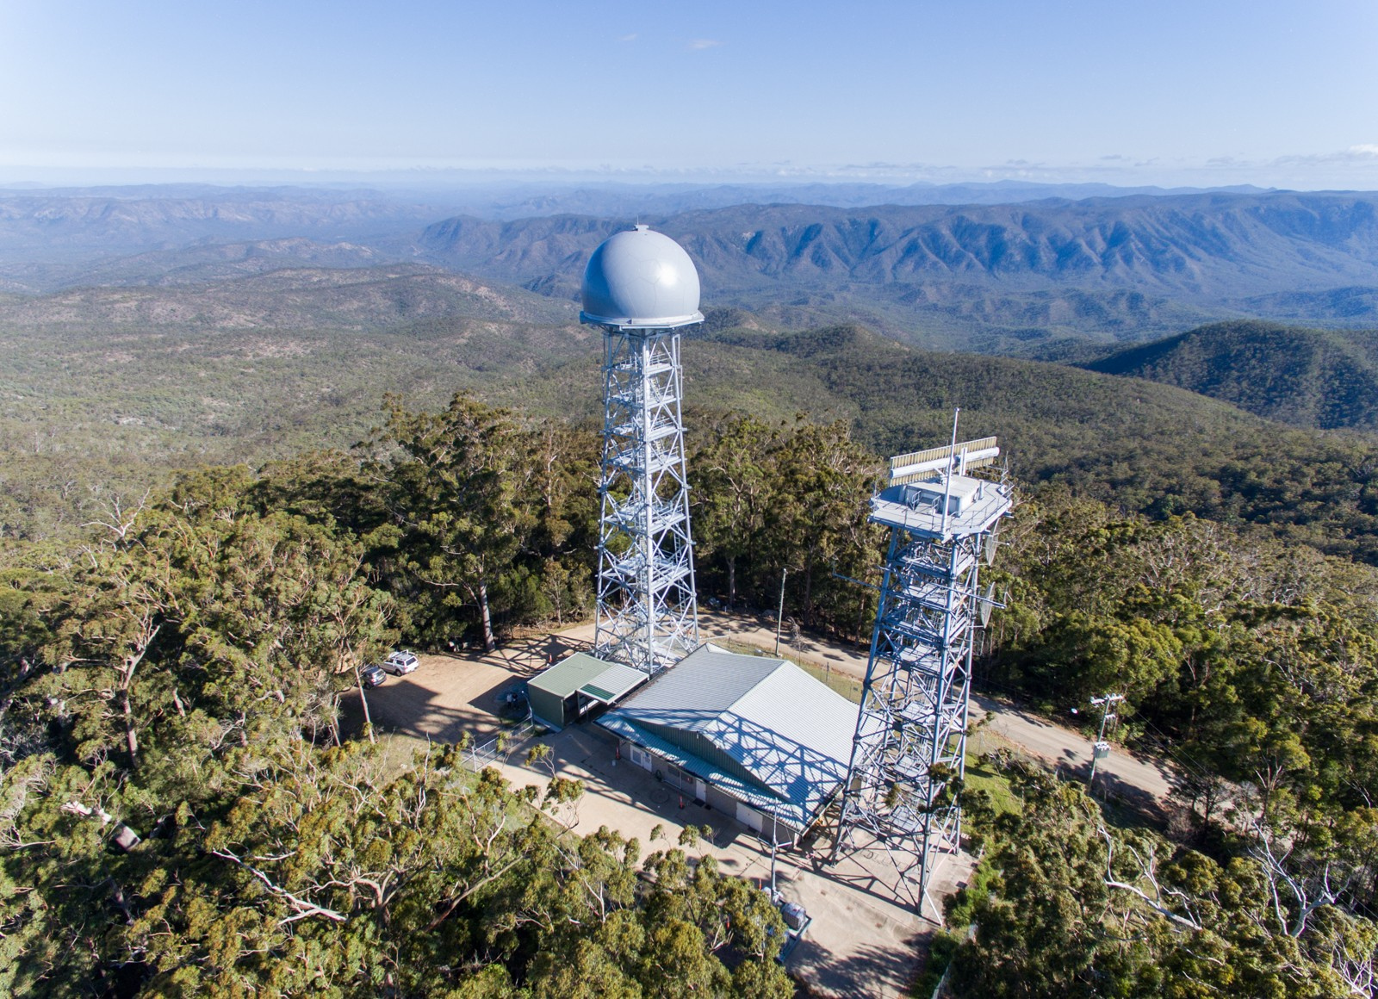

Figure 7 Indra MSSR Radar type used in this analysis